**Hands on 4**

**Spring Core – Load Country from Spring Configuration XML**

Solution-

**1. Picked up India as the country and configured ‘country.xml’.**

Country.xml-

<?xml version="1.0" encoding="UTF-8"?>  
<beans xmlns="http://www.springframework.org/schema/beans"  
 xmlns:xsi="http://www.w3.org/2001/XMLSchema-instance"  
 xsi:schemaLocation="  
 http://www.springframework.org/schema/beans  
 https://www.springframework.org/schema/beans/spring-beans.xsd">  
   
 <bean id="country"  
 class="com.cognizant.spring_learn.Country">  
 <property name="code" value="IN"/>  
 <property name="name" value="India"/>  
 </bean>  
  
</beans>

**2. Created country class with required code.**

Country.java-

package com.cognizant.spring_learn;  
  
import org.slf4j.Logger;  
import org.slf4j.LoggerFactory;  
  
public class Country {  
  
 private static final Logger *LOGGER* = LoggerFactory.*getLogger*(Country.class);  
  
 private String code;  
 private String name;  
  
 public Country() {  
 *LOGGER*.debug("Inside Country Constructor.");  
 }  
  
 public String getCode() {  
 *LOGGER*.debug("getCode() called");  
 return code;  
 }  
  
 public void setCode(String code) {  
 *LOGGER*.debug("setCode() called");  
 this.code = code;  
 }  
  
 public String getName() {  
 *LOGGER*.debug("getName() called");  
 return name;  
 }  
  
 public void setName(String name) {  
 *LOGGER*.debug("setName() called");  
 this.name = name;  
 }  
  
 @Override  
 public String toString() {  
 return "Country [code=" + code + ", name=" + name + "]";  
 }  
}

**3. Created a method displayCountry() in SpringLearnApplication.java, which will read the country bean from spring configuration file and display the country details.**

SpringLearnApplication.java-

package com.cognizant.spring_learn;  
  
import org.slf4j.Logger;  
import org.slf4j.LoggerFactory;  
import org.springframework.boot.SpringApplication;  
import org.springframework.boot.autoconfigure.SpringBootApplication;  
import org.springframework.context.ApplicationContext;  
import org.springframework.context.support.ClassPathXmlApplicationContext;  
  
@SpringBootApplication  
public class SpringLearnApplication {  
  
 private static final Logger *LOGGER* =  
 LoggerFactory.*getLogger*(SpringLearnApplication.class);  
  
 public static void displayCountry() {  
 ApplicationContext context = new ClassPathXmlApplicationContext("country.xml");  
 Country country = context.getBean("country", Country.class);  
 *LOGGER*.debug("Country : {}", country);  
 }  
  
 public static void main(String[] args) {  
 SpringApplication.*run*(SpringLearnApplication.class, args);  
 *displayCountry*();  
 }  
}

**4. Executed main() method.**

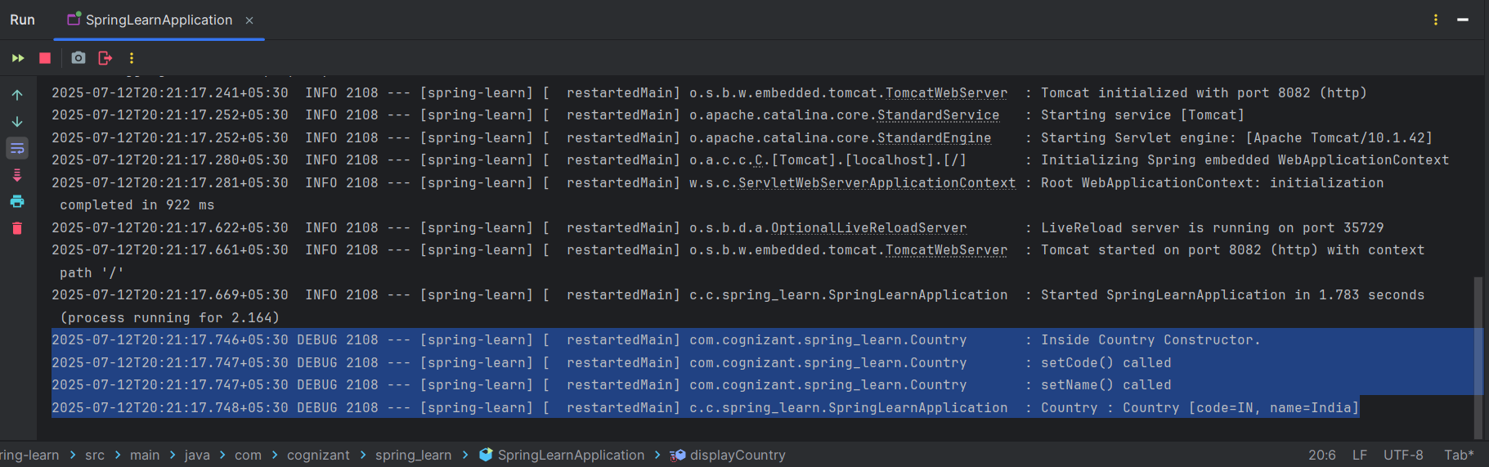Output-

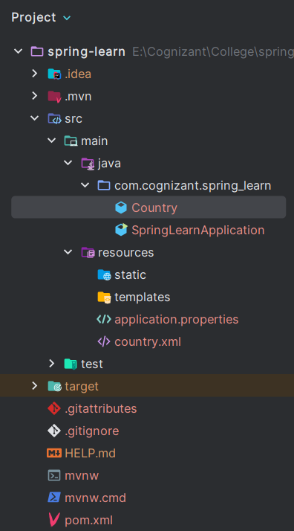5. Project Structure-